B.Tech. Computer Engineering
DEVANG SHAH
devangvshah16@gmail.com
+91 9326059054
llinkedin.com/in/devang-shah-63a29b210

github.com/Devang-Shah-49

EDUCATION
Dwarkadas J. Sanghvi College of Engineering
02/2021 - Present,
Achievements/Summary
Currently studying in First Year at DJSCE, Mumbai (Autonomous college affiliated to University of Mumbai). Also, actively participating in various college events and contests to boost my skills.

H.S.C.
SMPRS Junior College, Mulund
06/2019 - 03/2020,
Achievements/Summary
Successfully cleared Higher Secondary Certificate Exam under the Maharashtra State Board with an aggregate of 81.85%. Also cracked Competitive Entrance Examinations(JEE, CET, BITS) with flying colours.

S.S.C.

St. Xavier’s High School & Junior College, Powai
06/2017 - 03/2018,
Achievements/Summary
Bagged a good rank in Secondary School Certificate Exam under the Maharashtra State Board with an aggregate of 93.2%.
ACHIEVEMENTS
# Served as Red House team Leader in Secondary School for year 2015-16.
# Participated and achieved Olympiad medals for year 2016-17.
# Awarded with drawing certificate at City-level contest 2018.
# Certified from DJ Codestars + CodeChef for Code Uncode 4.0 held on 11th March, 2021.

# 2-Star Coder at Hackerrank.

# Awarded Prizes in various Drawing, Debate, Elocution, Quiz, and team events and contests.

LANGUAGES
Java
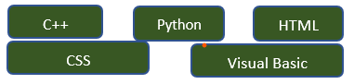

SKILLS
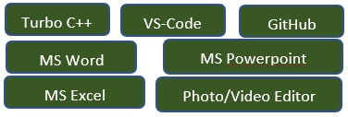

ACTIVITIES
# Participating in C++ Workshop by DJ Codestars, 2021.
# Participated in Web & App Development Workshop at HackPrep, DJ Unicode 2021.
# Participated in Python Workshop and Codatron at Oculus SPIT, 2021.
# Participated in Cin/Cout & Code-Uncode 4.0 contests on Hackerrank ,2021.
# Participated in GitUp & Open-source Workshop by DJ IEEE Brainwaves, 2021.

INTERESTS
Speech Telling Sports Dancing Reading

CAREER OBJECTIVE
To increase my academic knowledge and technical skills and be an expert in the domain through continuous learning, improvement and perseverance.
REFERENCES
Availabe upon requests

